Software Requirements Specification
for
Bug Tracker Application
Version 1.0 approved
Prepared by Group 12
University of Wollongong
20 August 2016
Table of Contents
Table of Contents ii
Revision History iii
1. Introduction 1
1.1 Purpose 1
1.2 Scope 1
1.3 Definitions, Acronyms and Abbreviations 2
1.4 References 2
1.5 Overview 2
2. Overall Description 3
2.1 Product Functions 3
2.2 User Classes and Characteristics 4
2.3 Operating Environment and Memory Constraints 5
2.4 Design and Implementation Constraints 5
2.5 Assumptions and Dependencies 6
3. External Interface Requirements 7
3.1 System Interfaces 7
3.2 User Interfaces 8
3.3 Hardware Interfaces 8
3.4 Software Interfaces 8
3.5 Communications Interfaces 9
3.6 Operations 9
4. Specific Requirements 9
5. Functional Requirements 10
5.1 Profile Subsystem 10
5.2 Bug Subsystem 16
5.3 Bug Report Subsystem 21
5.4 Search Subsystem 22
6. Other Nonfunctional Requirements 23
6.1 Performance Requirements 23
6.2 Safety Requirements 24
6.3 Security Requirements 25
6.4 Software Quality Attributes 26
7. Other Requirements 28
8. System Requirements Chart 28
Appendix A: User Interface Prototypes 29
Appendix B: To Be Determined List 40

Revision History
Name | Date | Reason For Changes | Version
Tessa Marelic | 20/8/2016 | Start of SRS | 1.0
Nathaniel Smith | 29/08/2016 | - Added Guest User  - Added Non Functional Requirements  - Changed ‘Manager’ to ‘Triager’ to fit client specifications  - Removed Developer Use case to decline a bug to fit client specifications | 1.1
Xinwei Jiang | 31/08/2016 | - Removed a duplicated Functional Requirement.  - Changed ‘source’ in functional requirements whose source is Reporter  - Changed the description about reputation functional requirement.  - Removed a functional requirement about reviewer, which is the same as providing comments. | 1.2
Tessa Marelic | 31/08/2016 | - Added guest user to 1.2 Scope  - Added 3 non-functional requirements  - Filled in communication interface  - Added overall system network | 1.3
Nathaniel Smith | 2/09/2016 | - Added Appendix A – User Interface Prototype ( 3.2 )  - Minor spelling mistakes  - Numbered Functional Requirements  - Numbered Tables and Figures | 1.4

Introduction

Purpose
This document describes all the requirements for Bug Tracker Version. Bug Tracker is a system that manages the life-cycle of various bugs reported by users of certain software. Contents of this document is pertinent to the entire system and incorporates all information needed to understand the system including a prototype.

Intended audience for this document is the software development team creating the application and the users of the system.

<Identify the product whose software requirements are specified in this document, including the revision or release number. Describe the scope of the product that is covered by this SRS, particularly if this SRS describes only part of the system or a single subsystem.>

This section describes the software very briefly, and notes if it is the whole system or part of a larger system. Very short.

Scope
The system being developed is a bug-tracking software application and will be referred to as Bug Tracker throughout this document.

Bug Tracker serves five types of users and is maintained by a systems administrator. Types of users are as follows:

- Guest:
A guest is an unregistered end user searching for information regarding an issue he/she is having with software.
- Reporter:
A reporter is an end user who has identified a bug in their software. The main reasons a reporter will use the site is to either peruse for existing information on bugs or report the bug so it can be fixed by a developer.
- Triager:
Responsible for managing all quality aspects of the bug such as assigning it to a developer, keeping track of a developer’s progress, checking for duplicate, invalid bugs and creating reports. The Triager monitors developers’ performances and assigns reputation statuses to each one.
- Developer:
Assigned to fix a bug by the Triager, they use the site to view bugs and communicate with the Triager and reporters on current fixes.
- Reviewer:
A reviewer is a tester, so tests software once the developer has released the latest fix. Reviewers use the site to communicate with developers and reporters on whether bugs have been sufficiently fixed and record testing observations.
- System Administrator:
Purpose is to administer the system by managing user privileges, system maintenance and monitoring security.
To accommodate all users the system is divided into four sub systems:

- A profile subsystem that manages all individual user profiles.
- Bug subsystem that manages a bug’s life-cycle. This will incorporate recording and displaying state changes and information related to the bug such as descriptions, discussions and registrations of interest.
- A search subsystem allows users to search for bugs through key words and filter search results.
- A Reporting subsystem with functionality to generate reports such as the number of bugs resolved and reported in a week, best performed reporters or developers, highest number of bugs for an application.

Definitions, Acronyms and Abbreviations

References
George Mason University Department of Computer Science, 2016, SRS_template.doc. Viewed on 20 August 2016,
cs.gmu.edu/~rpettit/files/project/SRS-template.

<List any other documents or Web addresses to which this SRS refers. These may include user interface style guides, contracts, standards, system requirements specifications, use case documents, or a vision and scope document. Provide enough information so that the reader could access a copy of each reference, including title, author, version number, date, and source or location.>

Any external document, specifications? If not, say “None.”

Overview
This document is divided into two main parts:
Overall Description and Interfaces (section 2 and 3) describes general factors that affect the system and provides information on interfaces. Included in the interfaces section is a prototype to test if the system meets all requirements.
- The Specific Requirements (section 4, 5 and 6) describe all functional and non-functional requirements.

Overall Description

Product Functions
Primary function of Bug Tracker is to provide a facility to report, fix and track bugs found in software. Bug Tracker is designed to integrate into a company’s existing network design.
There are six types of users, Guests, Reporters, Developers, Reviewers, Triagers, System Administrator (see 2.2 User Classes and Characteristics for further clarification of users).
For Guests, Bug Tracker helps them to search for existing bugs already reported in the system. These users have limited access to the full system and as such can only:
- Search for an existing Bug
- Register to become a Reporter
For Reporters, Bug Tracker helps them get better use out of software available to them. When they report a bug in their software, it gets sent to the appropriate developer who then fixes it. Functions within Bug Tracker allow Reporters to:
- Report a bug
- Search for an existing bug
- Create and edit their own profile
- Subscribe to a bug
- Add a comment
- Produce bug reports
- Edit/remove own comments
- Search other users of the site and view their comments and reported bugs.
- Earn points for reporting bugs

For Developers, Bug Tracker creates an environment where they can find work and earn a good reputation within the software development industry. Developers have the same functionality as Reporters as well as:

- View a list of bugs to be fixed.
- Check a bug in or out to move it to a new status, e.g. in progress
- Ability to communicate with Triagers on the progress of the fix.

For Reviewers (otherwise known as testers), Bug Tracker is a resource where they find bug fixes to test before and after an update is released. Reviewers have the same functionality as Reporters as well as:

- View a list of fixed bugs
- Record the outcome of any testing on that bug.

For Triagers, Bug Tracker gives them a system to control and record the life-cycle of bugs. They can quickly generate reports on numbers of bugs, their fixes and other statistical data. It also gives them access to a pool of software developers for which they can distribute work. Triagers have the same functionality as Reporters, as well as:

- Assign bugs to developers
- Check for duplicates/invalid bugs
- Edit existing bugs
- View developers current assigned bug list
- Disable/enable a user account.

System Administrators are the super users of Bug Tracker hence they control the system. They have access rights of all users. Functionality that allows them to control the system includes:
- Import users from external databases or xml
- Add new users
- Remove existing users
- Edit existing user profiles
- Enable/disable user accounts
- View bugs assigned to developers

Functionalities are designed so the system is transparent, creating a community where reporters, developers and reviewers can interact and discuss issues with software.

User Classes and Characteristics
User classes and characteristics are as follows:

- Guests are users of the system that have not yet registered.

- Reporters are employees of a company who have Bug Tracker installed on their computers. They have a good understanding of the software applications they use to carry out their work tasks and will be technically savvy.
- Triagers are business professionals with a high level of technical expertise in managing IT systems and employees.
- Reviewers are generally people from IT backgrounds with a high level of technical expertise.
- Developers are people who come from computer science or IT backgrounds so have a diverse knowledge of programming languages, algorithms and data structures.
- System Administrators come from computer science or IT backgrounds with a sound knowledge of networking and databases.

<Identify the various user classes that you anticipate will use this product. User classes may be differentiated based on frequency of use, subset of product functions used, technical expertise, security or privilege levels, educational level, or experience. Describe the pertinent characteristics of each user class. Certain requirements may pertain only to certain user classes. Distinguish the most important user classes for this product from those who are less important to satisfy.>

Operating Environment and Memory Constraints
The application works on the following environments:
Windows 7, 8, 10
Mac OSX 10.8 and above
UNIX Systems

System Requirements:

4 GB ram
Database with at least 1 GB storage.
1 GB free hard drive space
1.16GHz processor
Network interface card
32mb client machine

<Describe the environment in which the software will operate, including the hardware platform, operating system and versions, and any other software components or applications with which it must peacefully coexist.>

This should be short, and mainly include what types of environments you support. If it’s a web-based product, this is browsers and versions. (Don’t say “all browsers”. There are hundreds of web browsers… SPECIFICALLY list which ones you will support.)

If it’s a (non-web) application, provide the environment: Windows Vista on a P4 100MHz and higher. Look at software specifications on the web, and see what they say.

Design and Implementation Constraints
The system should obey and satisfy the following:

- Programming language used for each subsystem must be written in C++ or Java.
- The system must implement a hierarchy of access control:
1. Base user is a Reporter who has the least access rights.
2. Reviewer has second level access rights.
3. Developer has third level access rights.
4. Triager has fourth level access rights.
5. System Administrator is the super user and has all access rights.
User authentication security should be included and each user given appropriate access rights.
- Back-up and recovery: data must be automatically backed up on a weekly basis and kept offsite for a minimum of 7 months.
- All developers of the system must use the same Ide and use a version control application.
- The first version of the system must be ready for release by 13th October 2016
<Describe any items or issues that will limit the options available to the developers. These might include: corporate or regulatory policies; hardware limitations (timing requirements, memory requirements); interfaces to other applications; specific technologies, tools, and databases to be used; parallel operations; language requirements; communications protocols; security considerations; design conventions or programming standards (for example, if the customer’s organization will be responsible for maintaining the delivered software).>

Assumptions and Dependencies
Assumptions and dependencies are as follows:

- All developers involved have a good understanding of C++ and NetBeans Ide.
- All developers have their own version of QT for interface creation.
- All users of the system are connected to a network.
- All users of the system have an email address.
<List any assumed factors (as opposed to known facts) that could affect the requirements stated in the SRS. These could include third-party or commercial components that you plan to use, issues around the development or operating environment, or constraints. The project could be affected if these assumptions are incorrect, are not shared, or change. Also identify any dependencies the project has on external factors, such as software components that you intend to reuse from another project, unless they are already documented elsewhere (for example, in the vision and scope document or the project plan).>

You may have some or None. Think about it though, if you write “none”, but it is obvious you should have some, I will deduct points!

External Interface Requirements

System Interfaces
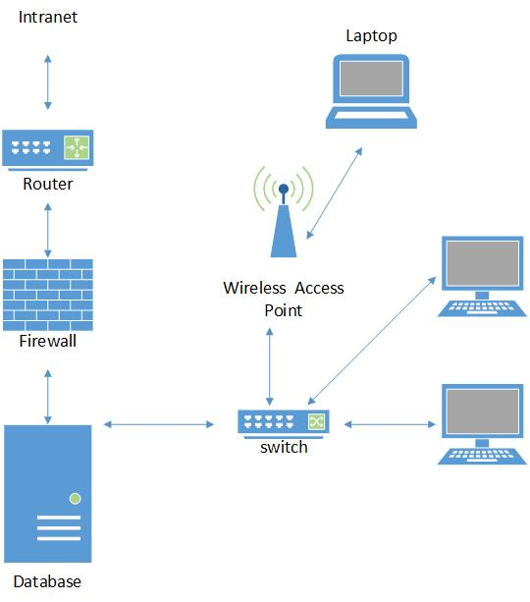
Figure 3.1-1 System Interface Diagram

3.2 User Interfaces
See Appendix A: User Interface Prototypes
<Describe the logical characteristics of each interface between the software product and the users. This may include sample screen images, any GUI standards or product family style guides that are to be followed, screen layout constraints, standard buttons and functions (e.g., help) that will appear on every screen, keyboard shortcuts, error message display standards, and so on. Define the software components for which a user interface is needed. Details of the user interface design should be documented in a separate user interface specification.>

Think about this in terms of standards, not specific features. For example,
- all buttons will have a black border
- all fonts will be Arial
- Draw a screen template showing “main area”, “menu here”, “status bar” and describe each component. If you have multiple screen layouts depending on the user’s current task/settings, describe them
- What screen resolutions will you support?
- Will you be Section 508 compliant? Are there any other standards you support?
- etc…

Hardware Interfaces
Supported devices include desktop computers and laptops. Laptops will need to connect to the wired network via wireless access points installed at various locations within the building.

<Describe the logical and physical characteristics of each interface between the software product and the hardware components of the system. This may include the supported device types, the nature of the data and control interactions between the software and the hardware, and communication protocols to be used.>

If you system doesn’t include hardware, then you’ll have none. If it has hardware components, then you should describe (at a high level) how you interface with that hardware.

Software Interfaces
User Interface
- Client desktop machines communicate with the server/database via a wired network, laptops connect to the wired network via TCP/IP together with Access Points.
<Describe the connections between this product and other specific software components (name and version), including databases, operating systems, tools, libraries, and integrated commercial components. Identify the data items or messages coming into the system and going out and describe the purpose of each. Describe the services needed and the nature of communications. Refer to documents that describe detailed application programming interface protocols. Identify data that will be shared across software components. If the data sharing mechanism must be implemented in a specific way (for example, use of a global data area in a multitasking operating system), specify this as an implementation constraint.>

These are internal connections to things like databases, web servers. You mainly need to explain that you have them, but (for CS421) I don’t expect detailed information about how you actually connect to them and use them. Just explain that you do connect to them and use them for storage of customer information, or to process incoming web requests, etc… These are internal components of your system.

Communications Interfaces
- Client machines will communicate via a wired network connection as well as wireless via TCP/IP and the use of access points.
- The web and database are located on the one server.
<Describe the requirements associated with any communications functions required by this product, including e-mail, web browser, network server communications protocols, electronic forms, and so on. Define any pertinent message formatting. Identify any communication standards that will be used, such as FTP or HTTP. Specify any communication security or encryption issues, data transfer rates, and synchronization mechanisms.>

These are external communication mechanisms. Do you connect to a bank computer to verify credit card information? That is NOT part of your system, so it is an external communication you have. Describe it here. Do you have other systems connecting in to yours to perform some function? That would also go here.

Operations
The audience of Bug Tracker are all technically competent, professionals so they expect a comprehensive interface that caters to all their needs.

Installation should be straight forward and won’t require extra networking skills to install.
A contingency plan must be in place in case of disaster or loss of power.

Specific Requirements
Each requirement (functional or non-functional) for Bug Tracker is based on a level of importance:

- Critical: highest importance level. These reflect core functionality and must be implemented.
- Essential: second highest importance level. Reflect important functionality and must be implemented after the critical requirements.
- Desirable: medium importance level. These reflect necessary but not critical functionalities and implemented when all critical and essential requirements are complete.
- Optional: lowest importance level. Optional requirements may extend higher level requirements but are not essential. Implemented when all critical, essential and desirable requirements are complete.

Functional Requirements

Profile Subsystem
This section explains functional requirements Bug Tracker must provide to Reporters, Developers, Triagers and Reviewers within the Profile Subsystem:

Requirements Common to all users:

Requirement #: F_5.1.1 | Requirement Type:  Functional | Use case #: SA_01
Description: The system should provide a Guest to Register an account in the system. Account details include First Name, Last Name, Username, Password, and Email Address.
Rationale: Guest wants to Register to the system
Source: Guest
Fit Criterion: The account has been successfully registered.
Dependencies: Account must not already exist
Rank of importance: Essential
Supporting Materials: None
History:
- Created by Nathaniel Smith 06/08/2016
Table 5.1-1
Requirement #: F_5.1.2 | Requirement Type: Functional | Use Case 2
Description: The system should provide a user of any type (Reporter, Developer, Triager, and Reviewer) with a GUI form to login. The GUI will allow the user to enter their email as their username and enter a password
Rationale: A user wants to login
Source: Reporter, Developer, Triager, Reviewer
Fit Criterion: The user logs in successfully
Dependencies: User profile must exist, see requirement 1
Rank of Importance: Essential
Supporting Materials: None
History:
Created by Tessa Marelic 6/8/2016
Modified by Xinwei Jiang 31/8/2016
Table 5.1-2

Requirement #: F_5.1.3 | Requirement Type: Functional | Use Case 3
Description: The system should provide a user with information on how to submit a bug.
Rationale: A reporter wants to know how to report a bug
Source: Reporter, Developer, Triager, Reviewer
Fit Criterion: Users can successfully submit a bug.
Dependencies: None
Rank of Importance: Desirable
Supporting Material: None
History:
Created by Tessa Marelic 8/8/2016
Modified by Xinwei Jiang 31/8/2016
Table 5.1-3
Requirement #: F_5.1.4 | Requirement Type: Functional | Use Case 4
Description: The system should provide any user with a GUI to modify profile details, name, phone, address, and password.
Rationale: A user wants to modify profile details
Source: Reporter, Developer, Triager, Reviewer
Fit Criterion: Profiles can be successfully changed.
Dependencies: username and password must exist and checked, profile must exist (requirement 1)
Rank of Importance: Essential
Supporting Material: None
History:
Created by Tessa Marelic 8/8/2016
Modified by Xinwei Jiang 31/8/2016
Table 5.1-4
Requirement #: F_5.1.5 | Requirement Type:  Functional | Use case #: SA_01
Description: The system should provide a user with a GUI form to search for users of any type.
Search criteria include: First Name, Last Name, Email, Role, Account
Status and Key word.
Rationale: A user wants to search for user profiles.
Source: Reporter, Developer, Triager, Reviewer
Fit Criterion: A GUI search form for users should be displayed.
Dependencies: None
Rank of importance: Essential
Supporting Materials: None
History:
- Created by Nathaniel Smith 06/08/2016
- Modified by Xinwei Jiang 31/8/2016
Table 5.1-5
Requirement #: F_5.1.6 | Requirement Type:  Functional | Use case #: SA_01
Description: The system should provide a user with a GUI to view any non-administrator user profile. A profile consists of First Name, Last Name, User Name, Password
(Cannot be viewed), Email, Addresses, Account Status, Role (required), Date of Birth.
Rationale: A user wants to view any profiles.
Source: Reporter, Developer, Triager, Reviewer
Fit Criterion: The profile should be viewed successfully.
Dependencies: The to-be-viewed profile must exist. Refer to F_3.1.1.1_04.
Rank of importance: Critical
Supporting Materials: None
History:
- Created by Nathaniel Smith 06/08/2016
- Modified by Xinwei Jiang 31/8/2016
Table 5.1-6
Requirement #: F_5.1.7 | Requirement Type:  Functional | Use case #: SA_01
Description: The system should allow a user to filter users of any type by First Name,
Last Name and Account Status. The purpose of filtering is to filter records of user profiles that are being currently displayed on the screen.
Rationale: A user wants to filter user profiles.
Source: Reporter, Developer, Triager, Reviewer
Fit Criterion: User profiles can be filtered successfully.
Dependencies: None
Rank of importance: Essential
Supporting Materials: None
History:
- Created by Nathaniel Smith 06/08/2016
- Modified by Xinwei Jiang 31/8/2016
Table 5.1-7

Requirement Specific to a Reporter:

Requirement #: F_5.1.8 | Requirement Type: Functional | Use Case 10
Description: The system should allow a Reporter, Developer, Triager, Reviewer to clock up reputation points to be displayed in their user profile and whenever their name is used in commenting or bug reporting or bug solving. Egg 5 good bugs reported, reporter is at level 1, 10 reporter at level 2 etc.
Rationale: A user wants to improve and display their reputation.
Source: Reporter, Developer, Triager, Reviewer
Fit Criterion: The system successfully records points that are calculated into levels for each user
Dependencies: A GUI to enter bugs must exist (requirement 5) and user profiles must exist (requirement 1)
Rank of Importance: Critical
Supporting Material: None
History: Created by Tessa Marelic 8/8/2016
Modified by Xinwei Jiang 31/08/2016
Table 5.1-8
Requirements Specific to an Administrator

Requirement #: F_5.1.9 | Requirement Type:  Functional | Use case #: SA_01
Description: The system should provide a System Admin with a GUI to import user profiles from external databases and/or xml files.
Rationale: System Admin wants to import user profiles from external databases and/or xml files
Source: System Admin
Fit Criterion: User profiles can be successfully imported.
Dependencies: None
Rank of importance: Essential
Supporting Materials: None
History:
- Created by Nathaniel Smith 06/08/2016
Table 5.1-9

Requirement #: F_5.1.10 | Requirement Type:  Functional | Use case #: SA_01
Description: The system should provide a System Admin with a command line interface to import user profiles from xml files.
Rationale: System Admin wants to import user profiles from xml files through command line
Source: System Admin
Fit Criterion: User profiles can be successfully imported.
Dependencies: None
Rank of importance: Optional
Supporting Materials: None
History:
- Created by Nathaniel Smith 06/08/2016
Table 5.1-10
Requirement #: F_5.1.11 | Requirement Type:  Functional | Use case #: SA_01
Description: The system should provide a System Admin with a GUI to add a new non-administrator user to the Bug Tracker System.
Rationale: System Admin wants to add new users to the Bug Tracker System
Source: System Admin
Fit Criterion: User account can be successfully added.
Dependencies: None
Rank of importance: Critical
Supporting Materials: None
History:
- Created by Nathaniel Smith 06/08/2016
Table 5.1-11
Requirement #: F_5.1.12 | Requirement Type:  Functional | Use case #: SA_01
Description: The system should provide a System Admin with a GUI to remove an existing non-administrator user in the Bug Tracker System.
Rationale: System Admin wants to remove existing users in the Bug Tracker System
Source: System Admin
Fit Criterion: User account can be successfully deleted.
Dependencies: The to-be-deleted profile must exist. Refer to F_3.1.1.1_04.
Rank of importance: Essential
Supporting Materials: None
History:
- Created by Nathaniel Smith 06/08/2016
Table 5.1-12
Requirement #: F_5.1.13 | Requirement Type:  Functional | Use case #: SA_01
Description: The system should provide a System Admin with a command line interface to add a new non-administrator user to the Bug Tracker System.
Rationale: System Admin wants to add new users to the Bug Tracker System from command line
Source: System Admin
Fit Criterion: User account can be successfully added.
Dependencies: None
Rank of importance: Optional
Supporting Materials: None
History:
- Created by Nathaniel Smith 06/08/2016
Table 5.1-13
Requirement #: F_5.1.14 | Requirement Type:  Functional | Use case #: SA_01
Description: The system should provide a System Admin with a command line interface to remove an existing non-administrator user in the Bug Tracker System.
Rationale: System Admin wants to remove existing users in the Bug Tracker System from command line
Source: System Admin
Fit Criterion: User account can be successfully deleted.
Dependencies: The to-be-deleted profile must exist. Refer to F_3.1.1.1_04.
Rank of importance: Optional
Supporting Materials: None
History:
- Created by Nathaniel Smith 06/08/2016
Table 5.1-14
Requirement #: F_5.1.15 | Requirement Type:  Functional | Use case #: SA_01
Description: The system should provide a System Admin with a GUI to edit an existing non-administrator user’s profile in the Bug Tracker System.
Rationale: System Admin wants to edit existing user’s profiles in the Bug Tracker System
Source: System Admin
Fit Criterion: User profiles can be successfully modified.
Dependencies: The to-be-edited account must exist. Refer to F_3.1.1.1_04.
Rank of importance: Essential
Supporting Materials: None
History:
- Created by Nathaniel Smith 06/08/2016
Table 5.1-15
Requirement #: F_5.1.16 | Requirement Type:  Functional | Use case #: SA_01
Description: The system should provide a System Admin with a GUI to disable/enable any non-administrator user profile.
Rationale: An administrator wants to disable/enable any non-administrator profiles.
Source: System Admin
Fit Criterion: The profile should be disabled/enabled successfully.
Dependencies: The to-be-enabled/disabled profile must exist. Refer to F_3.1.1.1_04.
Rank of importance: Essential
Supporting Materials: None
History:
- Created by Nathaniel Smith 06/08/2016
Table 5.1-16

Bug Subsystem
This section explains functional requirements Bug Tracker must provide to Reporters, Developers, Triagers and Reviewers within the Bug Subsystem:

Requirements for all users except guests

Requirement #: F_5.2.1 | Requirement Type: Functional | Use Case 5
Description: The system should provide a user with a GUI form to enter new bugs. The form should include:
- Application the reporter is reporting a bug on
- Title
- Text area to enter description of bug
- Option to receive responses from their post to their email
- Choose how often they want responses, e.g. weekly, monthly
- Optional information: Version, file uploads, repeatable walkthrough, platform, severity, priority
Rationale: A user wants to post a new bug
Source: Reporter, Developer, Triager, Reviewer
Fit Criterion: Bugs can be successfully submitted into the database
Dependencies: Username and password must exist and be checked (requirement 1), database must exist to store the bug details.
Rank of Importance: Critical
Supporting Material: None
History: Created by Tessa Marelic 8/8/2016
Modified by Xinwei Jiang 31/08/2016
Table 5.2-17

Requirement #: F_5.2.2 | Requirement Type: Functional | Use Case 9
Description: The system should provide any user with a facility to add comments
Rationale: A user wants to write comments about a particular bug.
Source: Reporter, Developer, Triager, Reviewer
Fit Criterion: Comments can be recorded and saved to the database.
Dependencies: Username and password must exist and be checked, the bug must exist in the database. Requirement 5.
Rank of Importance: Critical
Supporting Material: None
History: Created by Tessa Marelic 8/8/2016
Modified by Xinwei Jiang 31/08/2016
Table 5.2-18

Requirement #: F_5.2.3 | Requirement Type: Functional | Use Case 6
Description: The system should provide a user of any type (Reporter, Developer, Triager, and Reviewer) with a GUI form to subscribe to the bug. After subscribing to the bug, the user can get the newest information by E-mail once the information be updated.
Rationale: A user wants to subscribe bugs.
Source: Reporter, Developer, Triager, Reviewer
Fit Criterion: The user should subscribe the bugs successfully, and then the user can receive the newest information.
Dependencies: The bug’s information should exist.
Rank of Importance: Critical
Supporting Material: None
History: Created by Xinwei Jiang 8/17/2016
Table 5.2-19

Requirements Specific to a Triager:

Requirement #: F_5.2.4 | Requirement Type:  Functional | Use case #: SA_01
Description: The system should provide a Triager with a GUI to view all Bugs. This includes all active and non-active bugs including duplicate bugs
Rationale: Triager wants to view all Bugs in the System.
Source: Triager
Fit Criterion: Bugs are successfully displayed
Dependencies: None
Rank of importance: Critical
Supporting Materials: None
History:
- Created by Nathaniel Smith 06/08/2016
Table 5.2-20

Requirement #: F_5.2.5 | Requirement Type:  Functional | Use case #: SA_01
Description: The system should provide a Triager with a GUI to Assign bugs to developers. This GUI shows all currently un-assigned bugs and all developers.
Rationale: Triager wants to assign bugs to developers
Source: Triager
Fit Criterion: Bug successfully assigned to developer
Dependencies: Developer must exist.
Rank of importance: Critical
Supporting Materials: None
History:
- Created by Nathaniel Smith 06/08/2016
Table 5.2-21

Requirement #: F_5.2.6 | Requirement Type:  Functional | Use case #: SA_01
Description: The system should provide a Triager a GUI to Check for duplicate and/or invalid bug submissions and take appropriate actions regarding the bug.
Rationale: Triager wants to check for duplicate and invalid bug submissions.
Source: Triager
Fit Criterion: Invalid and/or duplicate bugs displayed.
Dependencies: None.
Rank of importance: Essential
Supporting Materials: None
History:
- Created by Nathaniel Smith 06/08/2016
Table 5.2-22

Requirement #: F_5.2.7 | Requirement Type:  Functional | Use case #: SA_01
Description: The system should provide a Triager with a GUI to edit existing Bugs in the System. Details such as title, description, status, severity, priority, assigned developer can be changed
Rationale: Triager wants to edit an existing Bug in the System.
Source: Triager
Fit Criterion: Bug Report successfully modified.
Dependencies: Bug must exist.
Rank of importance: Essential
Supporting Materials: None
History:
- Created by Nathaniel Smith 06/08/2016
Table 5.2-23

Requirement #: F_5.2.8 | Requirement Type:  Functional | Use case #: SA_01
Description: The system should provide a Triager with a GUI to view current bugs assigned to each developer.
Rationale: Triager wants to view bugs currently assigned to developers.
Source: Triager
Fit Criterion: Bugs assigned to developers are displayed.
Dependencies: None.
Rank of importance: Essential
Supporting Materials: None
History:
- Created by Nathaniel Smith 06/08/2016
Table 5.2-24

Requirement #: F_5.2.9 | Requirement Type:  Functional | Use case #: SA_01
Description: The system should provide a Triager with a GUI to disable/enable any Reported Users Account.
Triager can disable Reporters Account for the following reasons:
- Negative Reputations
- Duplicate Account
- Trolling
Rationale: A Triager wants to disable/enable any Reporters profiles.
Source: Triager
Fit Criterion: The profile should be disabled/enabled successfully.
Dependencies: The to-be-enabled/disabled profile must exist. Refer to F_3.1.1.1_04.
Rank of importance: Essential
Supporting Materials: None
History:
- Created by Nathaniel Smith 06/08/2016
Table 5.2-25

Requirements Specific to a Reviewer

Requirement #: F_5.2.10 | Requirement Type: Functional | Use Case 3
Description: The system should provide a reviewer with a GUI form to test the bug with its patches.
Rationale: A reviewer wants to test the bug with its patches
Source: Reviewer
Fit Criterion: The user tests the bug with its patches successfully.
Dependencies: The bug should be fixed by the developers.
Rank of Importance: Critical
Supporting Material: None
History: Created by Xinwei Jiang 8/10/2016
Table 5.2-26

Requirements Specific to a Developer:

Requirement #: F_5.2.11 | Requirement Type: Functional | Use Case 4
Description: The system should provide a facility for the developer to change the status of the bug. A developer can only change a bug assigned to them.
Rationale: A developer wants to change status of a bug
Source: Developer
Fit Criterion: The System has successfully changed the status
Dependencies: User profile must exist, bug must have been reported
Rank of Importance: Critical
Supporting Material: None
History: Created by Toby 8/10/2016
Table 5.2-27

Requirements Specific to a System Administrator:

Requirement #: F_5.2.12 | Requirement Type:  Functional | Use case #: SA_01
Description: The system should provide a System Admin with a GUI to view current bugs assigned to each developer.
Rationale: Admin wants to view bugs currently assigned to developers.
Source: System Admin
Fit Criterion: Bugs assigned to developers are displayed.
Dependencies: None.
Rank of importance: Essential
Supporting Materials: None
History:
- Created by Nathaniel Smith 06/08/2016
Table 5.2-28

Bug Report Subsystem
This section explains functional requirements Bug Tracker must provide to Reporters, Developers, Triager and Reviewers within the Reporting Subsystem:

Requirement specific to a Reporter

Requirement #: F_5.3.1 | Requirement Type:  Functional | Use case #: SA_01
Description: The system should provide a Reporter with a GUI to export Bug Reports into a word document, pdf or html file. This can include all statistical analysis of the System.
Rationale: Reporter wants to display Bug Reports
Source: Reporter, Developer, Triager, Reviewer
Fit Criterion: Bug Report successfully exported
Dependencies: User Profile must exist
Rank of importance: Critical
Supporting Materials: None
History:
- Created by Nathaniel Smith 06/08/2016
- Modified by Xinwei Jiang 31/08/2016
Table 5.3-29

Search Subsystem
This section explains functional requirements Bug Tracker must provide to Reporters, Developers, Triager and Reviewers within the Search Subsystem:

Requirements Common to All

Requirement #: F_5.4.1 | Requirement Type:  Functional | Use case #: SA_01
Description: The system should provide users a GUI form to search for bugs of any type.
Search criteria include: Application, Date, Developer, Key Word, and Status.
Rationale: A user wants to search for existing bugs.
Source: Reporter, Developer, Triager, Reviewer
Fit Criterion: A GUI search form for users should be displayed.
Dependencies: None
Rank of importance: Essential
Supporting Materials: None
History:
- Created by Nathaniel Smith 06/08/2016
- Modified by Xinwei Jiang 31/08/2016
Table 5.4-30

Requirement #: F_5.4.2 | Requirement Type:  Functional | Use case #: SA_01
Description: The system should allow a user to filter bugs of any type by Application,
Date, Developer and Status. The purpose of filtering is to filter records of bugs that are currently displayed on the screen.
Rationale: A user wants to filter bugs currently displayed
Source: Guest
Fit Criterion: Bugs can be filtered successfully.
Dependencies: None
Rank of importance: Essential
Supporting Materials: None
History:
- Created by Nathaniel Smith 06/08/2016
Table 5.4-31

Other Nonfunctional Requirements

Performance Requirements
Requirement #: NREQ_01 | Requirement Type: Performance | Use case #: NONE
Description: The system should be able to work 24 hours per day, seven days per week except during the maintenance time.
Rationale: All users want to use the system at any time (24 hours per day, seven days per week).
Source: Reporter, Developer, Reviewer, Triager, System Admin
Fit Criterion: Any authorised user can use the system at any time (24 hours per day, seven days per week).
Dependencies: None
Rank of importance: Essential
Supporting Materials: None
History:
- Created by Nathaniel Smith 26/08/2016
Table 6.1-32
Requirement #: NREQ_02 | Requirement Type: Performance | Use case #: NONE
Description: The system should respond to any action of any user within 12 seconds.
Rationale: A user wants to receive response to his action quickly.
Source: Reporter, Developer, Reviewer, Triager, System Admin
Fit Criterion: Any response to any user’s action should be performed within 30 seconds.
Dependencies: None
Rank of importance: Essential
Supporting Materials: None
History:
- Created by Nathaniel Smith 26/08/2016
Table 6.1-33
Requirement #: NREQ_03 | Requirement Type: Performance | Use case #: NONE
Description: The system should display search results within 12 seconds.
Rationale: A user wants to receive results of his query quickly.
Source: Reporter, Developer, Reviewer, Triager, System Admin
Fit Criterion: Search results should be displayed within 30 seconds
Dependencies: None
Rank of importance: Essential
Supporting Materials: None
History:
- Created by Nathaniel Smith 26/08/2016
Table 6.1-34
Requirement #: NREQ_04 | Requirement Type: Performance | Use case #: NONE
Description: The system should generate a report within no more than 2 minutes.
Rationale: A user wants to have a report quickly.
Source: Reporter, Developer, Reviewer, Triager, System Admin
Fit Criterion: Each report should be generated within 30 seconds
Dependencies: None
Rank of importance: Essential
Supporting Materials: None
History:
- Created by Nathaniel Smith 26/08/2016
Table 6.1-35
<If there are performance requirements for the product under various circumstances, state them here and explain their rationale, to help the developers understand the intent and make suitable design choices. Specify the timing relationships for real time systems. Make such requirements as specific as possible. You may need to state performance requirements for individual functional requirements or features.>

In this section, just say “See section 7 requirements 23-27”. And I’ll assume those requirements are Performance related.

Safety Requirements
Requirement #: NREQ_05 | Requirement Type: Safety | Use case #: NONE
Description: If the system is violated in the form of any type of hacking, it will shut down within 5 seconds of infiltration.
Rationale: The system will keep confidential profile information safe from hackers.
Source: Reporter, Developer, Reviewer, Triager, System Admin
Fit Criterion: The system is safe to use.
Dependencies: None
Rank of importance: Essential
Supporting Materials: None
History:
- Created by Tessa Marelic 31/08/2016
Table 6.2-36

<Specify those requirements that are concerned with possible loss, damage, or harm that could result from the use of the product. Define any safeguards or actions that must be taken, as well as actions that must be prevented. Refer to any external policies or regulations that state safety issues that affect the product’s design or use. Define any safety certifications that must be satisfied.>

In this section, just say “See section 7 requirements 25-32”. And I’ll assume those requirements are Safety related.

Security Requirements
Requirement #: NREQ_06 | Requirement Type: Security | Use case #: NONE
Description: The system should only allow passwords that comply with the following:
- At least ONE uppercase and ONE lowercase character
- No special characters, only alphanumeric
- No punctuation
- Not a previously used password by the user.
- Minimum length of 8
- Maximum length of 64
Rationale: To increase security of the system
Source: Reporter, Developer, Reviewer, Triager, System Admin
Fit Criterion:
Dependencies: None
Rank of importance: Essential
Supporting Materials: None
History:
- Created by Nathaniel Smith 26/08/2016
Table 6.3-37
Requirement #: NREQ_07 | Requirement Type: Security | Use case #: NONE
Description: The system should expire all passwords after 90 days and require users to change them prior.
Rationale: To increase security of the system
Source: Reporter, Developer, Reviewer, Triager, System Admin
Fit Criterion:
Dependencies: None
Rank of importance: Essential
Supporting Materials: None
History:
- Created by Nathaniel Smith 26/08/2016
Table 6.3-38
<Specify any requirements regarding security or privacy issues surrounding use of the product or protection of the data used or created by the product. Define any user identity authentication requirements. Refer to any external policies or regulations containing security issues that affect the product. Define any security or privacy certifications that must be satisfied.>

In this section, just say “See section 7 requirements 35-42”. And I’ll assume those requirements are Security related.

Software Quality Attributes
Requirement #: NREQ_08 | Requirement Type: Usability | Use case #: NONE
Description: The system should not require users to have any specific knowledge or special technical skill to be able to use it. Bug Tracker system should be appropriate for a computer-literate user community with no additional training on the system so that users can use it after at most one day of exploring the system. By providing well-formed graphical user interfaces.
Rationale: Users want to use the system without having to take any training records on the system.
Source: Reporter, Developer, Reviewer, Triager, System Admin
Fit Criterion: The users can use Bug Tracker system after at most one day of exploring the system.
Dependencies: None
Rank of importance: Essential
Supporting Materials: None
History:
- Created by Nathaniel Smith 26/08/2016
Table 6.4-39
Requirement #: NREQ_09 | Requirement Type: Usability | Use case #: NONE
Description: The system should provide users with appropriate feedback to recover from errors within 3 seconds by providing informative error messages.
Rationale: Users want to use the system without worrying about making errors.
Source: Reporter, Developer, Reviewer, Triager, System Admin
Fit Criterion: The users can easily recover from errors
Dependencies: None
Rank of importance: Essential
Supporting Materials: None
History:
- Created by Tessa Marelic 31/08/2016
Table 6.4-40
Requirement #: NREQ_10 | Requirement Type: Reliability | Use case #: NONE
Description: The system should be able to recover from failure after no more than 48 hours.
Rationale: The system should recover from failure as soon as possible to support 24/7 services.
Source: Reporter, Developer, Reviewer, Triager, System Admin
Fit Criterion: The system should recover after no more than 24 hours.
Dependencies: None
Rank of importance: Essential
History:
- Created by Nathaniel Smith 26/08/2016
Table 6.4-41
Requirement #: NREQ_11 | Requirement Type: Reliability | Use case #: NONE
Description: The system should be able to support up to 1000 simultaneous users at any time.
Rationale: To support simultaneous usage of the system.
Source: Reporter, Developer, Reviewer, Triager, System Admin
Fit Criterion: The system should successfully allow 1000 simultaneous users at any time.
Dependencies: None
Rank of importance: Essential
Supporting Materials: None
History:
- Created by Nathaniel Smith 26/08/2016
Table 6.4-42
Requirement #: NREQ_12 | Requirement Type: Reliability | Use case #: NONE
Description: The system should be able to store at least 1000 user profiles and 1000 bug reports.
Rationale: To support multiple users across the system
Source: Reporter, Developer, Reviewer, Triager, System Admin
Fit Criterion:
Dependencies: None
Rank of importance: Essential
Supporting Materials: None
History:
- Created by Nathaniel Smith 26/08/2016
Table 6.4-43

Requirement #: NREQ_13 | Requirement Type: Dependability | Use case #: NONE
Description: The system should have the ability to deliver a service that can be trusted by users by quantifying the reputations of developers and reporters.
Rationale: The system should be trustworthy to users
Source: Reporter, Developer, Reviewer
Fit Criterion: The system should quantify and display the reputations of reporters and developers.
Dependencies: None
Rank of importance: Essential
Supporting Materials: None
History:
- Created by Tessa Marelic 31/9/2016
Table 6.4-44
<Specify any additional quality characteristics for the product that will be important to either the customers or the developers. Some to consider are: adaptability, availability, correctness, flexibility, interoperability, maintainability, portability, reliability, reusability, robustness, testability, and usability. Write these to be specific, quantitative, and verifiable when possible. At the least, clarify the relative preferences for various attributes, such as ease of use over ease of learning.>

Other Requirements
<Define any other requirements not covered elsewhere in the SRS. This might include database requirements, internationalization requirements, legal requirements, reuse objectives for the project, and so on. Add any new sections that are pertinent to the project.>

You may not have any.

System Requirements Chart
< Include a table in this section with the following columns:

ID – Unique requirement ID
Priority – Priority of this requirement
Type – Functional (F) or Non-functional (NF)
Source – Who is most interested in this requirement (John Smith – Customer). For this project you can make it up, in reality you’ll want to capture this as you capture the requirements.
Contained in Use Case(s) – Which use cases reference this requirement or which use cases when executed will perform this requirement. There may be a few functional requirements without a use-case and the non-functional requirements generally will NOT be part of a use-case (so put N/A).
Description – The description of the requirement. “The system shall …. “
>

These requirements should match up with your use case diagrams.

Appendix A: User Interface Prototypes

3.2.1 Login
Each user is presented with this screen when the program is first executed. They must log in to continue and access the BugTracker system.

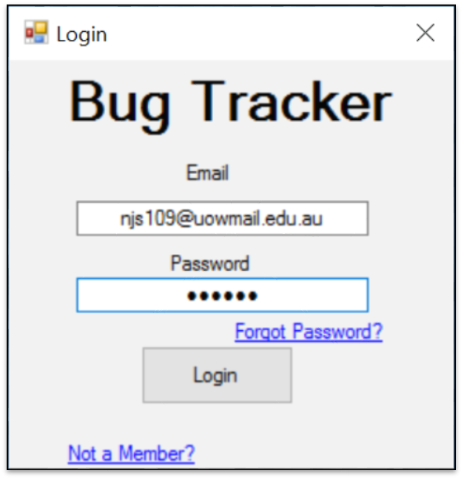

Figure 3.2.1 Login

The user has 3 options from this point, they can either:
- Log in using their email and password
- Select the Forgot Password link, which presents them with a GUI to send a request to the System Administrator to reset their password
- Select the Not a Member link, which will present them with additional information to either continue as a guest with limited access, or to register as a Reporter.

3.2.2 Guest Register
This screen is shown when a guest user wants to use the BugTracker System.
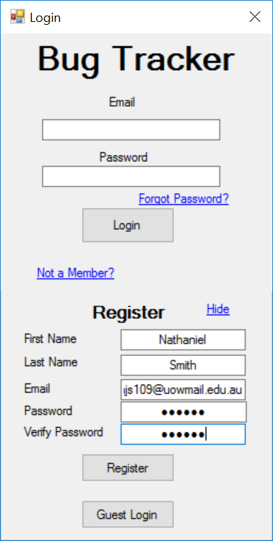

Figure 3.2.2 Guest Login

The guest can then choose to either:
- Register their email into the system to become a Reporter
- Continue as a guest user with limited access

3.2.3 Main Screen / Search Bug Screen
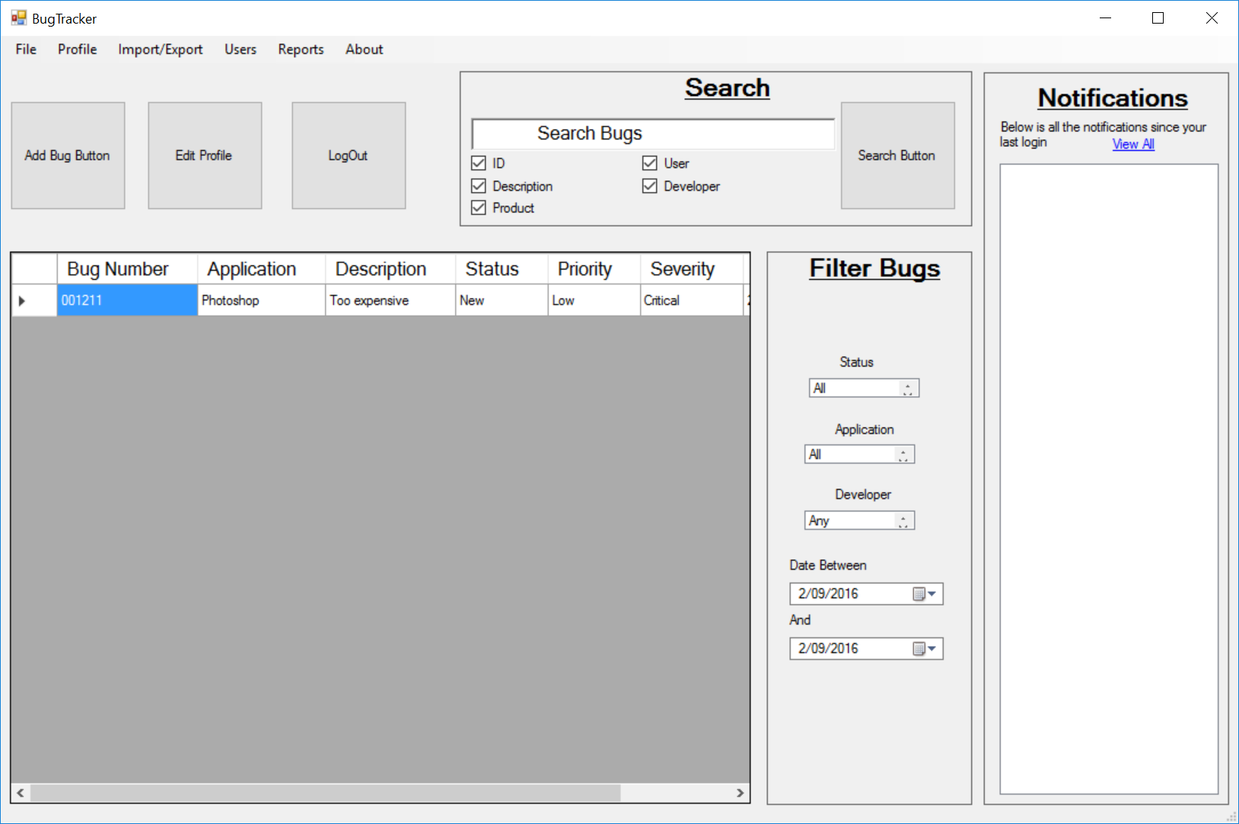
This is the main GUI that every user sees after they have logged into the BugTracker System.
Figure 3.2.3 Main Screen
This GUI is where most of the functions can be accessed. This screen has the following features:
- Bug List – this is a table format showing the results of the bug search function and filter functions. Default shows the latest 30 bugs in the database.
- Search Box – this is where a user can use keywords to search the database for any bugs related to their search criteria. The user can search by Bug ID, Bug Description, Product, User and Developer, or any combination of the above.
- Filter Bugs – this function allows the user to filter the search results. The user can filter the bugs by; Status, Application, Developer and by Dates Between.
- Menu Strip – the menu items within this strip are subject to change depending on the user who logged in, Import/Export is a System Administrator function.
- Notification Box – this is where the user receives their notifications from their subscribed bugs and any System related messages.

3.2.4 Add Bug
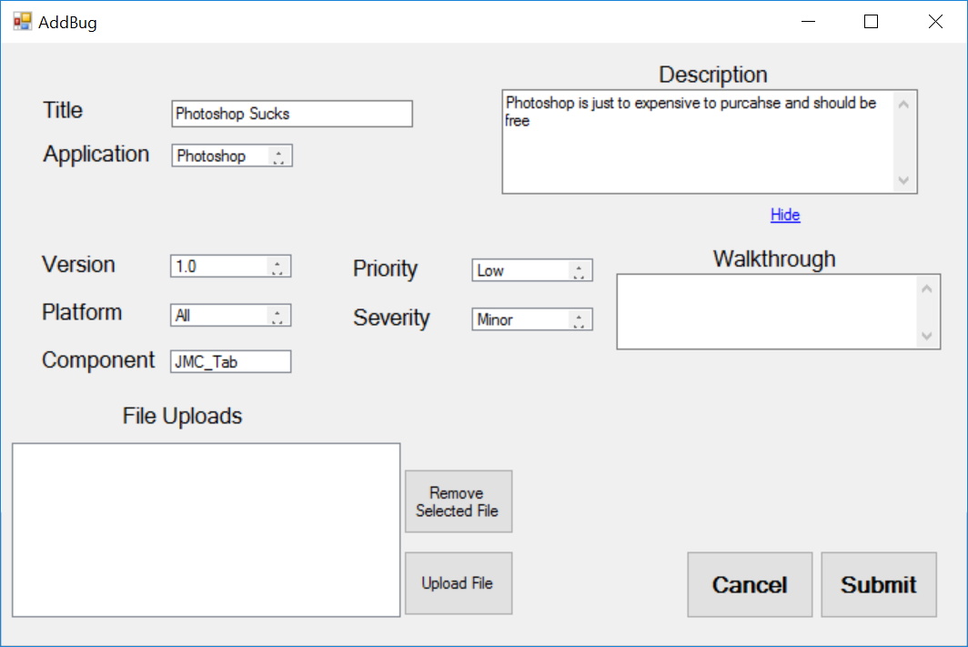
This GUI is where any user (excluding guest) can Report a bug into the BugTracker System.
Figure 3.2.4 Add Bug GUI

This GUI allows a user to Report a bug into the system.
It is divided into 3 sections:
- Top – this sections holds the mandatory fields required to submit a bug, the Title, Application and a short Description of the bug.
- Middle – this section can be hidden/unhidden by the user and holds the input fields for the optional information such as version, priority and Walkthrough.
- Bottom – this section is used to upload any files the user wished to add to the bug, such as screenshots, log files. Also contains buttons for submitting and cancelling.

3.2.5 View Bug
This GUI shows users information about a Bug already in the BugTracker System
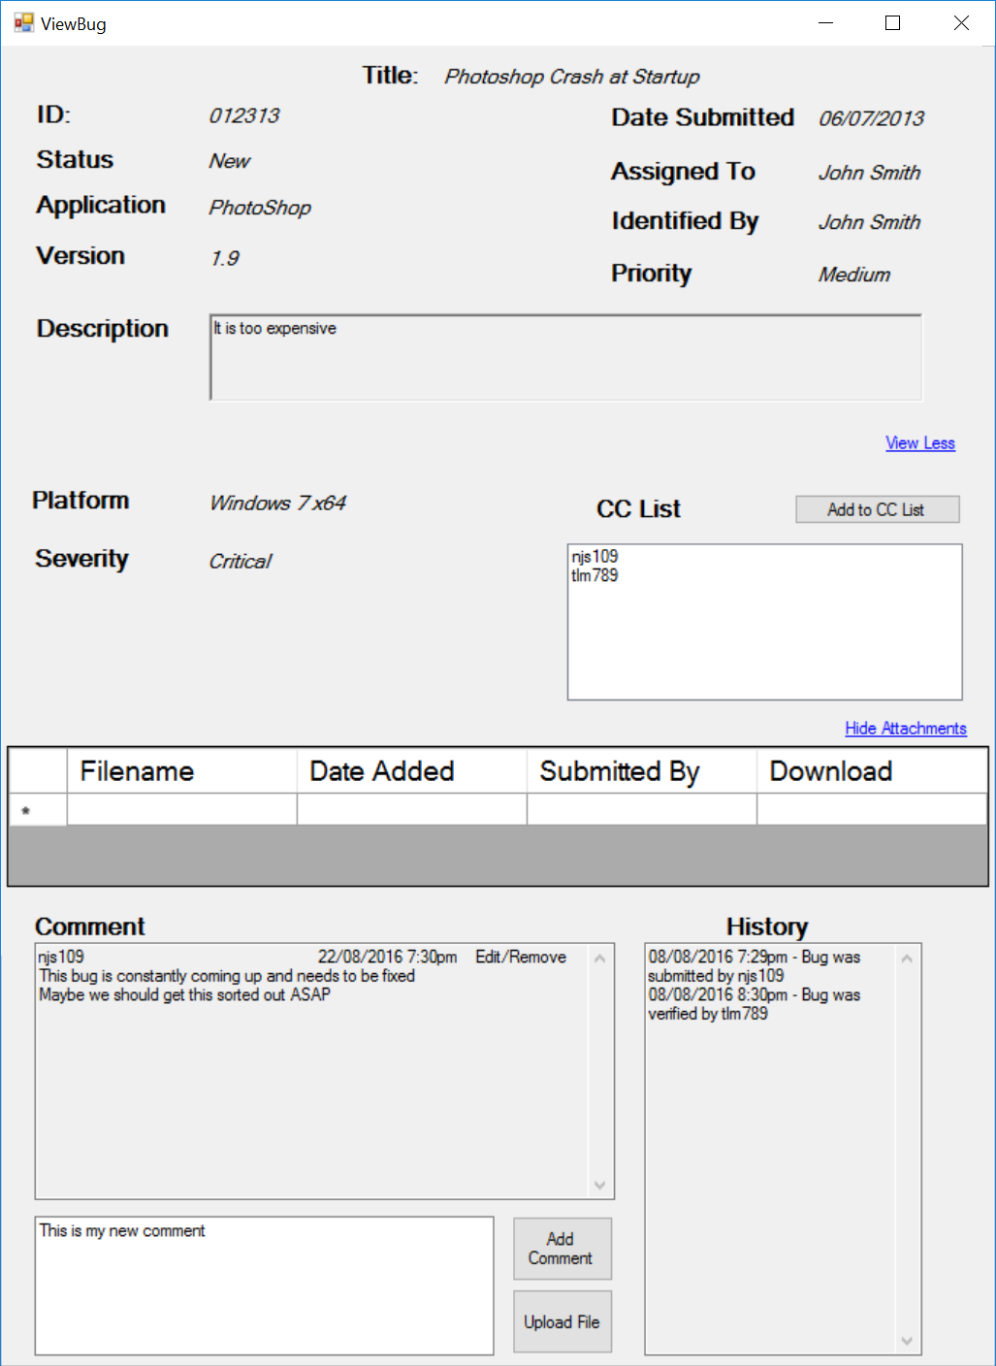

Figure 3.2.5 View Bug

This GUI shows all the information on the currently selected bug.
This view is divided into 4 sections:
- Top Section – shows the basic information about the bug, such as ID, Title, version, Application, date submitted and developer assigned to it.
- First Middle – contains further information including the platform severity and the CC list of all users who are currently subscribed to receive updates.
- Second Middle – shows a list of all the attachments associated with the bug.
- Bottom Section – this section shows the comments and history of the bug.

3.2.6 Edit Bug
This GUI is for Triagers to manage an existing bug in the BugTracker System.
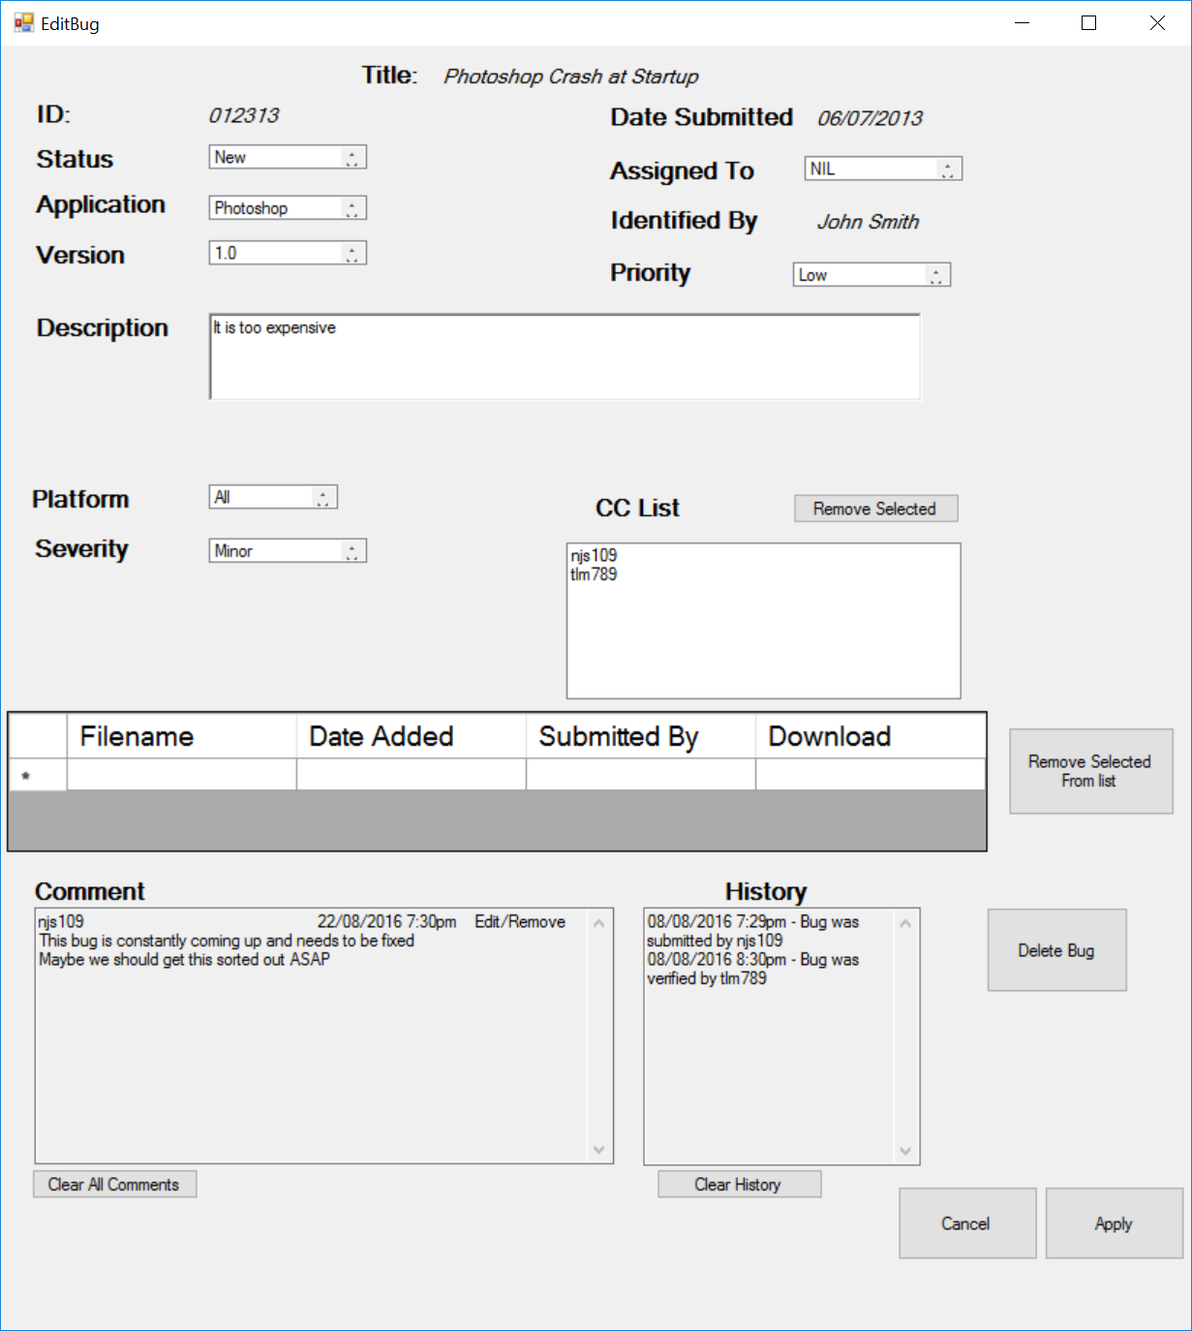

Figure 3.2.6 EditBug

This GUI is similar to the above ViewBug GUI but contains editable text areas to allow a Triager to update and modify details about the bug, including its lifecycle. This screen also allows the Triager to assign the bug to a particular developer. Other functions include:
- Remove users from CC list
- Remove attached Files
- Clear comments
- Clear History
- Delete the bug

3.2.7 Search User
This GUI is available to all registered users and allows users to search for other users within the BugTracker system and view their profile.
Figure 3.2.7 Search User
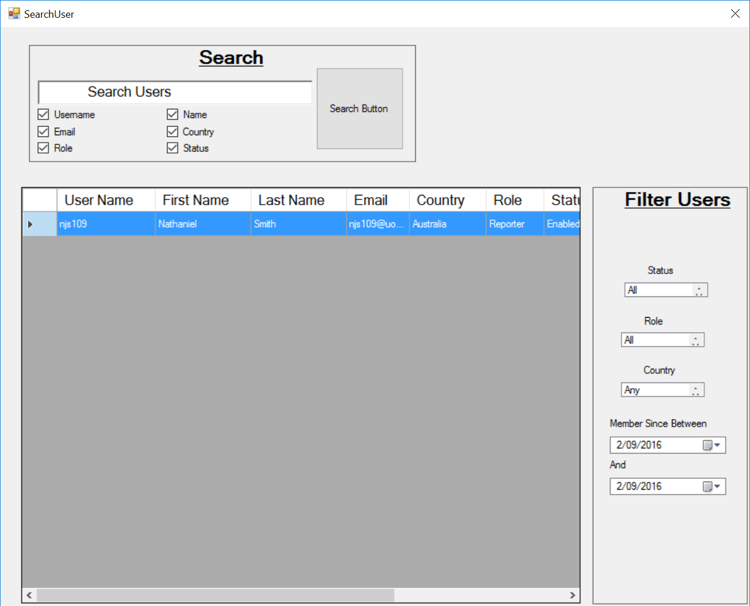

This GUI allows users to search for existing users within the BugTracker System
Features such as:
- User List – this is a table format showing the results of the user search function and filter functions. Default shows all users in the database.
- Search Box – this is where a user can use keywords to search the database for any users related to their search criteria. The user can search by username, name, email, country, role, or any combination of the above.
- Filter User – this function allows the user to filter the search results. The user can filter the users by; Status, Role, Country and by Dates Between.

3.2.8 View Profile
This GUI shows a user’s profile information. This is accessed by searching the system for users.
Figure 3.2.8 View Profile
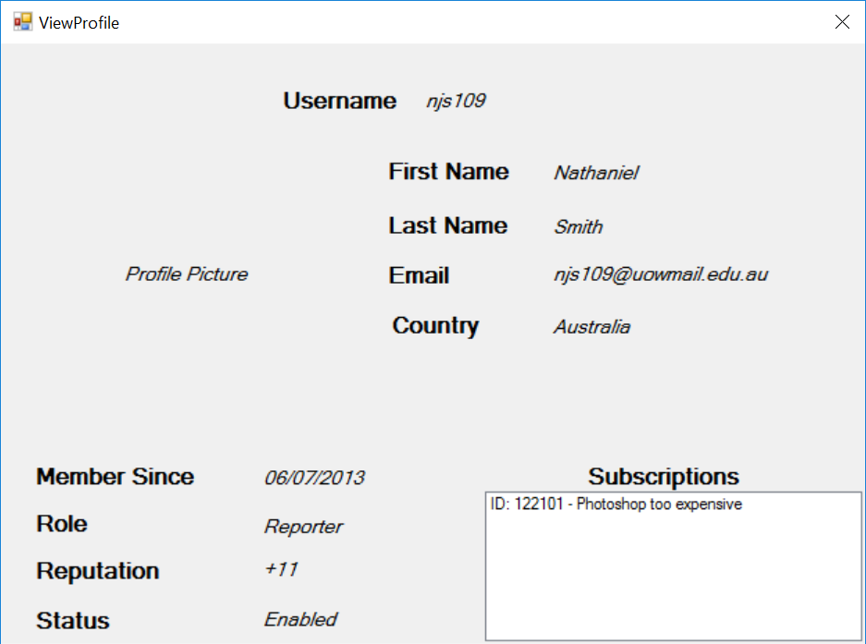

This GUI is a read-only form that shows details of the user. This is a public profile and all information is available for viewing by all users of the system. Information shown includes:
- Username
- First Name
- Last Name
- Email
- Country
- Profile Picture
- Role
- Reputation
- Status
- Date Added to system
- Current subscriptions

3.2.9 Edit Profile
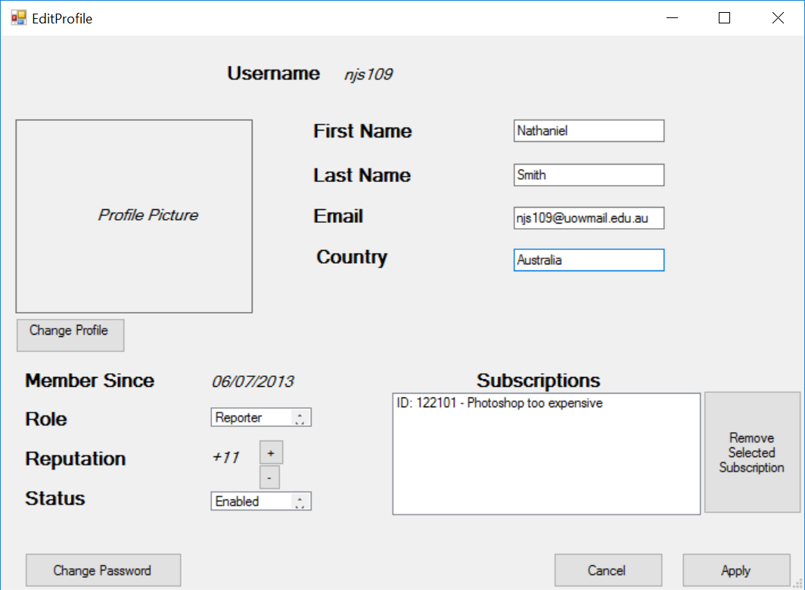
This GUI allows a user to edit their own profile, and a System Administrator to edit all profiles.
Figure 3.2.9 Edit Profile

This GUI is one that differs depending on the user logged in. Each user can edit their own profile, and System Administrator can edit any user’s profile.

Each user can change the following information on their own profile:
- First Name
- Last Name
- Email
- Country
- Subscriptions
- Password
- Profile Picture
They cannot change their reputation, role or status.
System Administrators have access to change the following information on any profile:
- First Name
- Last Name
- Email
- Country
- Profile Picture
- Password(reset not view)
- Reputation
- Role
- Status (Ban the user)

3.2.10 Add User
This GUI is for System Administrators and is used to Add a New User to the BugTracker System.
Figure 3.2.10 Add User
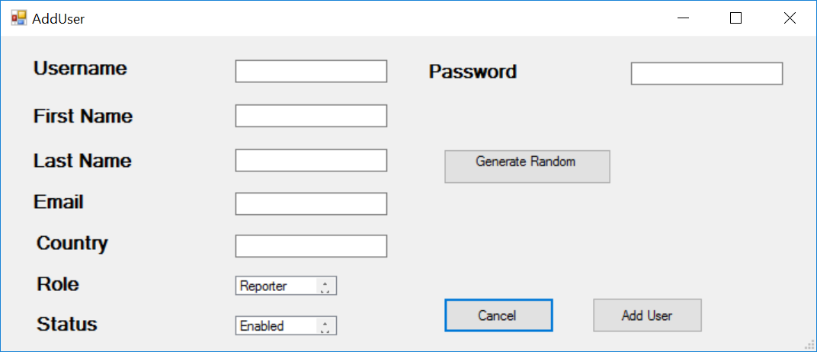

This GUI allows the System Administrator to enter details about the new user and can generate a random password for that user. Once the user has been created, an email is sent to their email containing their random password.

3.2.11 Import

This GUI is for System Administrator to import users and bugs into the BugTracker System.
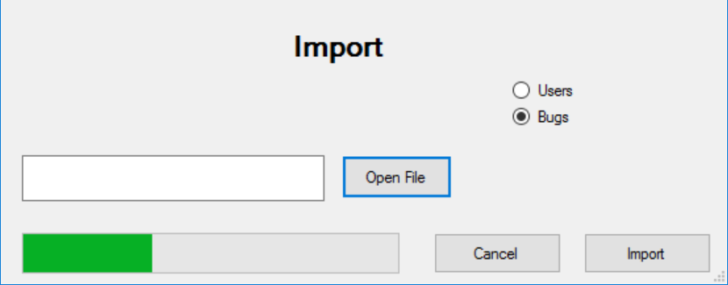
Figure 3.2.11

This GUI allows the System Administrator to import a XML or CSV File containing either Users or Bugs into the BugTracker System.

3.2.12 Export
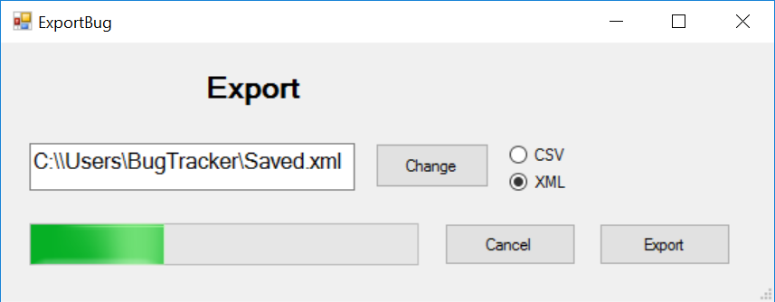
This GUI is for System Administrators to export Users and Bugs from the BugTracker System.
Figure 3.2.12 Export
This GUI allows a System Administrator to export currently selected Users or Bugs (from Search Users and Search Bug GUI) to XML or CSV files.
This allows them to backup and transfer data to and from other systems or incorporate them in 3rd party programs.

Appendix B: To Be Determined List
<Collect a numbered list of the TBD (to be determined) references that remain in the SRS so they can be tracked to closure.>

List here any open questions or things you know still need to be done to the SRS, but haven’t been addressed yet. (It’s okay to have things like that, especially in this CS421 project because we don’t have time to do everything.)

